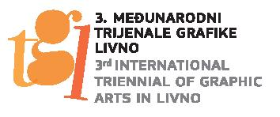

Number: D-34/2022.
Livno, February 15, 2022
SUBJECT: Invitation to the 3rd International Triennial of Graphic Arts Livno

Dear Madam or Sir,

The Franciscan Museum and Gallery Gorica Livno, organiser of the International Triennial of Graphic Arts Livno is pleased to announce its 3rd event, which will be held from June 26th to October 1st 2023. Thus, the Franciscan Museum and Gallery Gorica Livno continues to promote contemporary graphic practice in the country and the world. The theme of the 3rd International Triennial of Graphic Arts Livno is: Limits of Freedom. Following current events, but also having the fundamental human need for freedom of expression in mind, the primordial question of the notion of freedom arises also in present times. The organiser wishes that artists, through artistic freedom, speak not only of ideals, but also of the fundamental human need for the free act.
We invite you to be a part of the 3rd International Triennial of Graphic Arts Livno and to enrich the programme of the Triennial with your participation and your individual artistic expression, as well as to witness the stimulating impulses of traditional graphic practice, which has its regenerating dimension in contemporary art.
In the hope of achieving a successful collaboration in the building of new cultural and artistic bridges, we welcome you and look forward to your participation at the 3rd International Triennial of Graphic Arts in Livno.
Sincerely,

Museum director: Dražena Džeko

Attachment: Regulations of the Triennial

